Build from scratch
Let me search the workspace for assets related to "Customer Performance."
I found a sales_analytics project and several customer-related tables. Let me explore further to understand the full data structure.
Let me read the key notebooks to understand the data model and sales fact table structure.
I've found your sales_analytics project with bronze layer tables. Let me query the data to build a customer performance summary.
Now let me also check promotion participation and regional performance for a complete picture.
Here's the Customer Performance summary based on your sales_analytics project data:
Customer Performance Overview
| Customer | Region | Type | Transactions | Total Qty | Total Net Sales | Avg Order Value | Products |
| -------------- | ------- | --------- | -----------: | --------: | --------------: | --------------: | -------: |
| Costco East | EAST | Wholesale | 1 | 300 | $4,200 | $4,200 | 1 |
| Target West | WEST | Retail | 1 | 200 | $2,350 | $2,350 | 1 |
| Walmart East | EAST | Retail | 2 | 175 | $1,930 | $965 | 2 |
| Kroger Central | CENTRAL | Retail | 1 | 50 | $560 | $560 | 1 |
| Publix South | SOUTH | Retail | 0 | — | — | — | 0 |

Key Insights
Top customer: Costco East leads with $4,200 in net sales from a single large wholesale order (300 units).
EAST region dominates with $6,130 total sales across 2 customers (63% of all sales).
Walmart East is the most active buyer — 2 transactions across 2 different products, though with a lower average order value ($965).
Publix South has zero sales — no transactions recorded yet, representing an untapped opportunity.
3 active promotions are running: Target West ($75K expected revenue), Walmart East ($50K), and Kroger Central ($25K).

Break and fix
Genie Prompt
Who are my active customers?

Your data doesn't say what an active customer is, and depending on the definition there could be 6 or none. Neither table has a status or "active" flag, and the two Genie spaces don't define the term either.
Taking active to mean "has bought something", 6 customers in
sales_transactionstiger_assignment.tiger_bronze.sales_transactions
qualify:
Two things to know before using this list:
- Time window: the latest sale was on 2026-01-14, about 9.5 months ago. If active means a purchase in the last 30 or 90 days, none of these customers count.
- Customer table doesn't match: the 10 customers in
customertiger_assignment.tiger_bronze.customer
use different IDs (1001–1010, against C001–C006 in sales), so none of them join to any sales. Some names look alike, such as "Walmart East" and "Walmart", but that's only a guess, not a confirmed link.

Fix: Active customer = purchased in current fiscal year

Who are my active customers?
Active Customers (FY2026)
You have 6 active customers, meaning they purchased at least one product during Fiscal Year 2026 (January-December 2026)
Customer | Transactions | Sales ($) | Last Purchase
Walmart (C001) | 2 | 2,700.75 | 2026-01-08
Aldi (C004) | 2 | 2,550.75 | 2026-01-14
Carrefour (C002) | 2 | 2,300.50 | 2026-01-11
Tesco (C003) | 2 | 2,070.75 | 2026-01-13
Lidl (C006) | 1 | 980.00 | 2026-01-12
Target (C005) | 1 | 750.00 | 2026-01-10

Governance check
CREATE OR REPLACE VIEW tiger_assignment.tiger_bronze.vw_sales_secure AS

SELECT s.*
FROM tiger_assignment.tiger_bronze.sales_transactions s
JOIN tiger_assignment.security.user_country_access a
ON (
a.country = 'ALL'
OR s.country = a.country
)
WHERE lower(a.email) = lower(current_user());

SELECT DISTINCT country
FROM tiger_assignment.tiger_bronze.vw_sales_all;

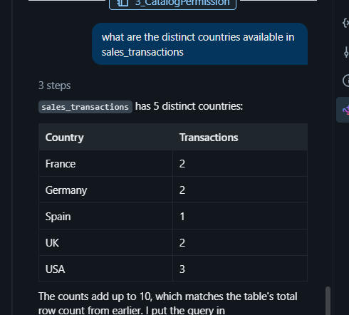

create the sql for the same how the output is generated

SELECT country, COUNT(*) AS transactions
FROM tiger_assignment.tiger_bronze.sales_transactions
GROUP BY country
ORDER BY country

Business handoff:**
Net Revenue:
Net Sales Analysis Summary
I've saved the business term definition:
Net Sales = Revenue after deductions
Net Sales Summary
Metric ValueTotal Net Sales $9,040
Total Quantity 725 Units
Total Transactions 5
Average Net Sales per Transaction $1,808
Largest Transaction $4,200
Smallest Transaction $560
Net Sales by Transaction (Ranked)
| Customer | Product | Brand | Qty | Net Sales | Net Price / Unit | Date |
| -------------- | ----------------- | -------- | --: | --------: | ---------------: | ---------- |
| Costco East | Mountain Dew 20OZ | MTNDEW | 300 | $4,200 | $14.00 | 2026-01-05 |
| Target West | Pepsi 12OZ | PEPSI | 200 | $2,350 | $11.75 | 2026-01-02 |
| Walmart East | Gatorade 500ML | GATORADE | 100 | $1,250 | $12.50 | 2026-01-01 |
| Walmart East | Lipton Tea | LIPTON | 75 | $680 | $9.07 | 2026-01-04 |
| Kroger Central | Propel Water | PROPEL | 50 | $560 | $11.20 | 2026-01-03 |

Net Sales by Brand
| Brand | Product | Total Net Sales | Qty |
| -------- | ----------------- | --------------: | --: |
| MTNDEW | Mountain Dew 20OZ | $4,200 | 300 |
| PEPSI | Pepsi 12OZ | $2,350 | 200 |
| GATORADE | Gatorade 500ML | $1,250 | 100 |
| LIPTON | Lipton Tea | $680 | 75 |
| PROPEL | Propel Water | $560 | 50 |

Key Insights
Mountain Dew drives 46% of total net sales ($4,200 out of $9,040) and commands the highest net price per unit at $14.00.
Costco East's single wholesale transaction generated $4,200, exceeding the combined net sales of the next two largest customer-product transactions.
Lipton Tea has the lowest net price per unit at $9.07, indicating either lower pricing or higher promotional discounts.
Walmart East is the only customer with multiple transactions, purchasing both Gatorade and Lipton Tea and contributing $1,930 (approximately 21% of total net sales).
All sales occurred between January 1 and January 5, 2026, indicating a highly concentrated sales period.

Hybrid retrieval

